Product Design Specifications

**Self-Balancing Unicycle**

for

**National Instruments**

Author(s):

**Carver, Spencer**

**Collins, Kevin**

**Solorzano, Ander**

**White-Magner, Ruffin**

Date:

**11/4/2012**

Revision Level:

**1**

Signatures

Client:_____________________________________________

Supervisor: _______________________________________________

Team Leader: _____________________________________________

Team Member 2: ______________________________________________

Team Member 3: ______________________________________________

Team Member 4: ______________________________________________

## Product Overview

This product is intended to be a demonstration unit for National Instruments at their NI Week 2013 convention. The unit should be able to balance on its own, and do so utilizing NI hardware and software (LabVIEW) where applicable. To ease transportation, the unit should easily be disassembled and reassembled. The unit will also be able to correct itself if slightly thrown off balance (e.g. pushed from behind).

## 1.1 Users

The designated users of the robot will be members of our senior design team, Robotics Capstone Design Team G, and National Instruments academic representatives and marketing and promotion employees. To work with the robot, there is no formal training required, though if one wishes to edit any of the controls for the robot, a knowledge of LabVIEW is necessary.

## 1.2 Product Function

The project consists of a self-balancing unicycle for National Instruments to showcase their products as a solution to complex robotic control problems. The robot will be self-balancing in the fact that it will be able to maintain an upright position without any outside help. The robot will address the problem of balancing in two dimensions so that it can withstand an impulse both the front/back and sides.

## 1.3 Performance and Capacity

The robot should be relatively stationary while maintaining a balanced upright position, thus making the robot easily avoidable and predictable. Specifically the robot should be able to remain within a radius that equal to its own height. Thus allowing the robot to fall over and remain relatively safe to demonstrate the operations within crowded environments. The robot should recover from slight external displacement (e.g. 10°) from the vertical to its point of contact on the ground.

## 1.4 Appearance and User Interface

The robot should also act as a promotional tool and as a public relations device promoting both Rose-Hulman’s students and the RH Robotics Department. The robot should include prominent logos promoting both parties.

## 1.5 Dimensions

The robot should be of sizable dimensions (e.g. 4’8’’x 8’’x1’8’’ as below) while being relatively small and compact for easy transportation and shipping. This should include, but is not limited to, detachable wheels, organized and clearly labeled electrical plugs, and mechanical components for easy assembly / disassembly.

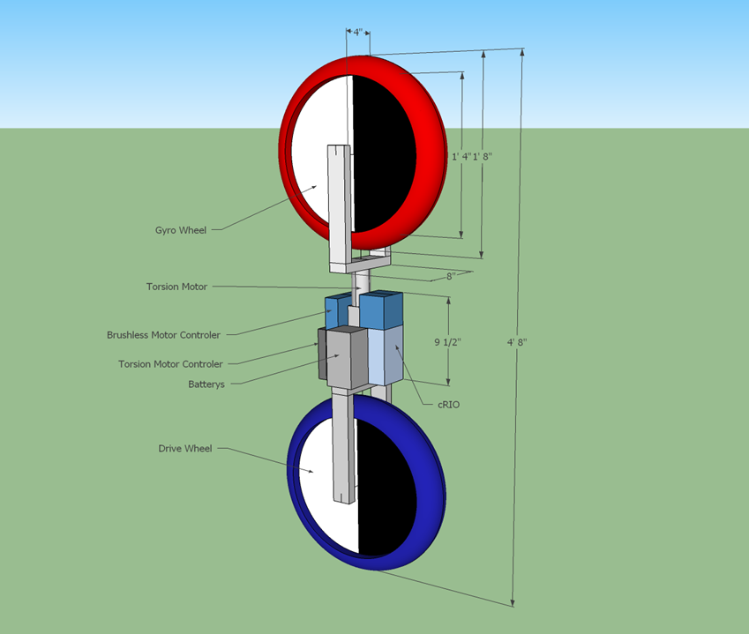

## 1.6 Mounting Requirements

Our robot will be self-standing and will not need to be mounted.

## 1.7 Compatibility

The robot should consist primarily of off-the-shelf parts and electronics for easy reproduction and repairs. The robot’s wheels should be of standardized bike tire sizes. The robot should function on standard and readily available battery voltages. The robot’s software will be compatible with the most recent versions of LabVIEW, but does not necessarily have to be backwards compatible with older versions of the software.

## 1.8 Connectors

The robot should utilize standardized connectors that are color coded and easily identifiable to avoid missed connections. The connectors should also be gender protected as an engineering precaution, such that the battery, motors, motor controllers, and cRio can only be connected in the intended configuration.

## 1.9 Power Supply

The robot should include support for more than one type of battery charger for the battery in use by the platform. Supported batteries should be available from more than one manufacturer and should be easily replaceable by a single individual for mid-demo replacement.

## 1.10 Design Constraints

Our robot must meet the following constraints

* Balance itself both forward and backward and side-to-side
* Be built with NI components where applicable
* Be programmed using NI LabVIEW Robotics Suite 2012
* Be built with off-the-shelf components where applicable

## 1.11 Fault Tolerance

The robot should be capable of withstanding tips and falls from an upright position, and resume working order. It should also enforce limits and safety precautions upon falling over to prevent further damage or harm. When the safety failsafe is active, all motors should be turned off and the state only deactivated once the robot has re-assumed an upright and stable position. The robot should also include limiters to avoid excessive strain on the equipment. This would encompass any situation where the motors would draw power in excess of their motor controllers standardized ratings, the motor controllers should shut off and cause the robot to assume its safety state.

## 1.12 Security

To prevent the unauthorized or unanticipated use of the robot, the system should include a method for enabling or disabling operation. This could include, but is not limited to, an ignition key, a code or passphrase.

## 1.13 Operating Environment

The robot’s design is suitable for indoor operations and storage, with all the parts specified to operate within room temperature (e.g. 80 to 60°F).

## 1.14 Standards

For project construction, standard sizes and dimensions should be used for all mechanical components, and should be available from more than one manufacturer.

Due to the private nature of this project (to be used internally by National Instruments), there are not many external compliance standards the project must meet. However, while our client has given us freedom to approach the problem and develop the solution in the way we deem most practical, we will also adhere to any standards that may be requested in the future, given a reasonable amount of time to do so.

## 1.15 Installation

The product will be constructed initially by the Robotics Capstone Design Team G, and will then be disassembled / reassembled by National Instruments representatives, and anyone they deem responsible for the product once it has left Rose-Hulman. Included with the project will be documentation and instructions for robot operation and assembly.

## 1.16 Maintenance

Since the robot is designed to be a demonstration piece, we would like to keep the design as modular as possible so that it can be easily adjusted and parts easily replaced depending on National Instruments requirements for the robot in the future. Due to the nature of the project, it is very likely that there will be some damages to it that accrue over time since it will fall down occasionally. Because of this, we want to keep easy maintenance in mind, using as few custom parts as possible and utilizing aluminum extrusion. The occasional bolt tightening will be required, but serious long term maintenance is not anticipated unless the robot is damaged during a demonstration or while being transported.

## 1.17 Manufacturing Cost

To create our project without any sponsorship from National Instruments, it would cost an estimated $27,000. However, a significant portion of this price (~$23,000) is solely in NI hardware and software that was provided to us at no charge. Therefore, our actual manufacturing cost will only be around $4000, largely stemming from the purchase of sensors.